Exploring Reflections Using Geogebra
Today, we are going to be using Geogebra to explore a type of transformation. Log on to your computers and open Geogebra.
- Using the polygon tool, create a triangle with vertices A(1,1), B(2,4) and C(5,2).
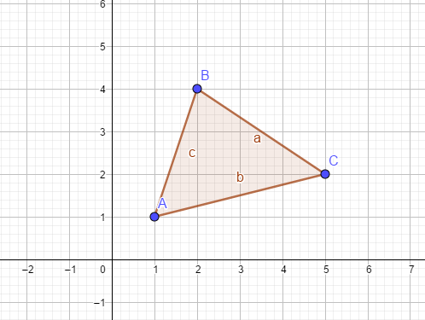
Reflection: A transformation in which a geometric figure is reflected across a line, creating a mirror image
Think: a reflection on a lake
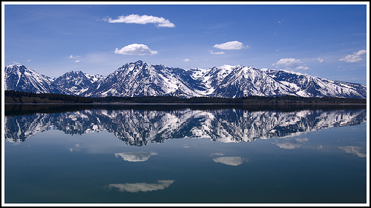

What is needed:
- A preimage
- A line of reflection

- Using the Reflection tool, click on triangle ABC and then the y-axis. The new reflected triangle will appear.
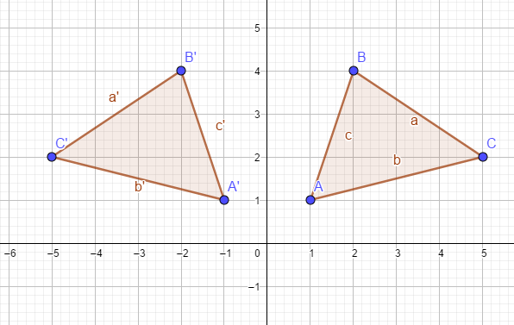
Line of Reflection:______________________
A(1,1) → A’(___ , ___)
B(2,4) → B’(___ , ___)
C(5,2) → C’(___ , ___)
What conjectures can be made about these sets of points? Consider the changes comparing the vertices of the preimage to the image.

- Using the Reflection tool, click on triangle ABC and then the x-axis. The new reflected triangle will appear.
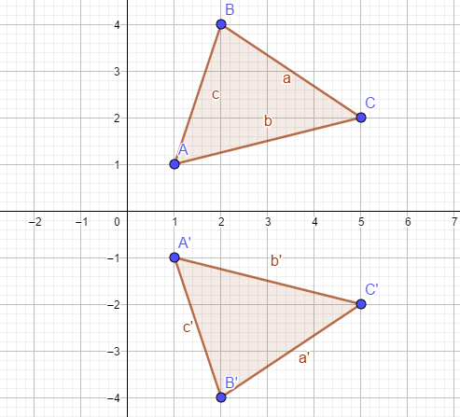
Line of Reflection:______________________
A(1,1) → A’(___ , ___)
B(2,4) → B’(___ , ___)
C(5,2) → C’(___ , ___)
What conjectures can be made about these sets of points? Consider the changes comparing the vertices of the preimage to the image.

Let’s see if this holds true for any line of reflection!
- Using the polygon tool, create triangle XYZ with vertices X(-1,3), Y(3,5), and Z(4,3). Then, using the line tool, graph the line y= -x+1.
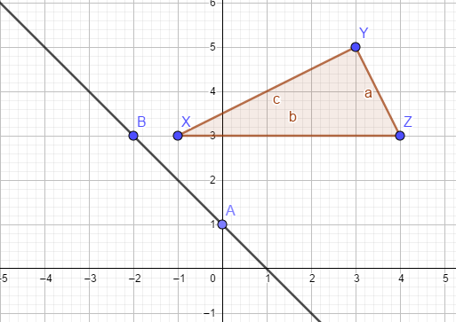
- Now, using the Reflection About Line Tool, create the image X’Y’Z’.
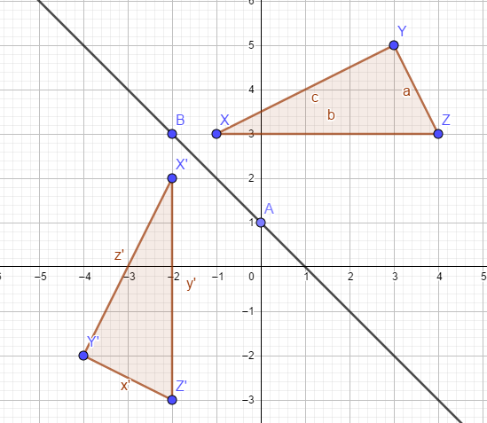
- Using the Distance tool, you can measure the distance between X and B, and X’ and B. Do the same for Y and Y’ and Z and Z’.

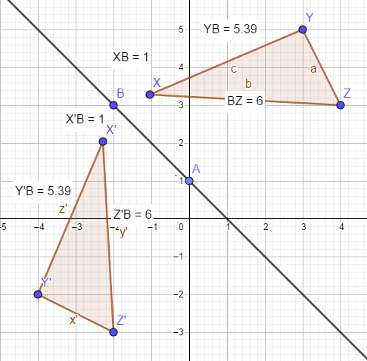
We can see that corresponding points are ___________________ from the line of reflection.
Click and drag point B to move the line of reflection and ensure that this claim holds true for any reflection!

Application activity: Sewing patterns of shirts and jackets
A pattern is a template that shows and explains shapes and measurements of fabric needed to construct a garment of clothing. Using a given pattern’s given measurements, recreate the shapes using the polygon tools in Geogebra. Then, perform reflections over several lines to show the fabric needed to create the garment. Then, determine the smallest amount of fabric needed to create the garment.

